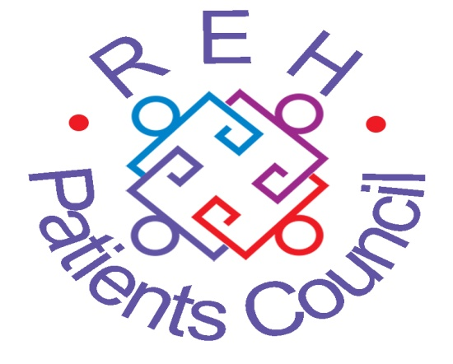

Date 30th June 2021

Senior Human Rights Educator post

Dear Applicant

Thank you for your interest in the above post with the Royal Edinburgh Hospital Patients Council, and for requesting an information pack. This post is offered for 35 hours per week, subject to a six month probationary period with a two-year fixed contract.
We will be considering both internal and external applications.

Enclosed you will find the following:

- Job Description
- Person Specification
- Application Form
- Protection of Vulnerable Groups Self Declaration Form
- Equal Opportunities Monitoring Form

Please fill in the application form, as appropriate, and return to us by the deadline of Wednesday 21st July 2021. Please ensure that you return the Protection of Vulnerable Groups Self Declaration Form by post as this should be signed. Your Equal Opportunities Monitoring Form should also be returned and can be sent by email or post. It will be stored separately to your application form and not seen by the selection panel.

If you are selected for interview, we intend to hold these on Thursday 5th August 2021.

Background information about the REH Patients Council can be found on the website – www.rehpatientscouncil.org.uk.

We look forward to receiving your completed application form in due course. Should you have any queries, then please contact the Patients Council office on 0131 537 6462 or Carolyn@rehpatientscouncil.org.uk

Yours faithfully

Carolyn Macpherson
Advocacy Organizer, Patients Council, REH

